CALL FOR PAPERS

The social science of religion:
Troeltsch, Weber, Simmel and others

International Conference
June 1-2, 2023
Cracow, Poland

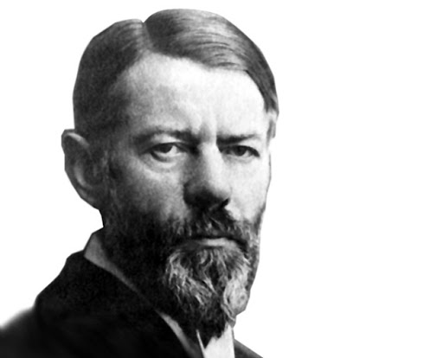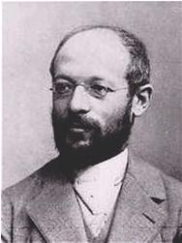
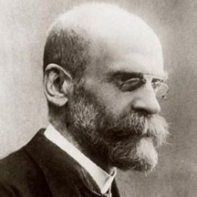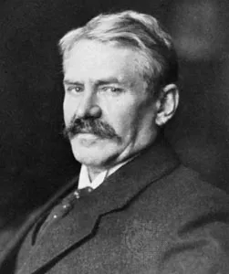

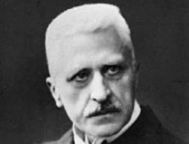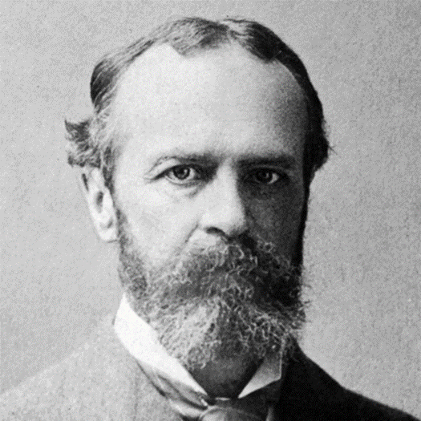

Invited keynote speakers:
Prof. Hans Joas(Humboldt-Universität)
Prof. Ulrich Schmiedel (Edinburgh University)

The year 2023 sees the centenary of Ernst Troeltsch’s death. Finding this a good occasion to re-visit Troeltsch’s work together with its broader context the Chair for Sociology of Religion at the Pedagogical University of Cracow would like to invite for the international conference The (social) science of religion: Troeltsch, Weber, Simmel and others. The main idea of the conference is to acknowledge and re-consider Troeltsch’s (rarely appreciated) role within the “visionary company” of great social scientists dealing with religion in the early 20th century.What we attempt is broad andinterdisciplinary reflection in which Troeltsch’s theological, philosophical and sociological approach together with the work of his contemporaries constitutes a point of departure. Submissions from sociologists, historians, theologians or philosophers are welcome. Different approaches to the main theme, both appreciative and critical, debates around heritage and questions of possible meanings that the “social science of religion” may have for (and in) our time – all this is of utmost interest to us. The list of possible topics includes:

- Troeltsch as a theologian and social scientist.Troeltsch has usually been treated as a theologian onlywhile his contributions to social sciences or philosophy of religion have been overlooked or simply forgotten. But this is as much pigeonholing as treating Weber solely as a “classic of sociology”. In fact what both Troeltsch and Weber offer is a broad synthesis of theology, sociology, history and philosophy.

- Troeltsch and his contemporaries – mutual inspirations and influences. Troeltsch has long been in the shadow of Weber and only recently was the importance of his work for social sciences and our reflection on modernity re-discovered.The samemore or less can be said of Simmel.

- Troeltsch’s multidisciplinary “science of religion” among similar projects by Weber, Simmel Durkheim or James

- Visions of modernity and secularization in the writings of Troeltsch, Max Weber, Georg Simmel,Émile Durkheim or William James: parallels and differences.

- Protestant Reformation in the writings of Troeltsch and Weber. The mutual influence of Troeltsch’s account of the birth of modernity out of the spirit of Protestantism and Weber’s theses about Reformation and capitalism is now indisputable. The question which may be asked today is which of these two accounts seem more relevant and inspiring from today’s perspective.

- Mutual interactions between theology and social sciences in Troeltsch and other representatives of the “science of religion”.

- Religion, historical consciousness and the question of values in Troeltsch and in the social science of the early 20th century.

- The question of “public function” and political responsibilities of both social science and theology according to Troeltsch, Weber, Simmel or James.

The conference will be held on 1-2June 2023at the Pedagogical University of Cracow in Cracow, Poland. The precise venue will be announced later.

Abstracts of max. 300 words together with a short cv should be sent to:

science.of.religion.conference@gmail.com

The deadline for abstracts is 28 February 2023. Authors will be notified of the acceptance of their submissions by 15 March 2023.

Conference languages are English and Polish.

Fee options:

200 PLN/50 EUR – participation on-site
250 PLN/80 EUR – participation + lunches on June 1 and 2
300 PLN/100 EUR – participation + lunches + conference dinner on June 1

Abstract submitters are kindly asked to choose one of the options.

All other costs, including transport and accommodation,should be covered separately by the participants. Cracow is a typical tourist city so there are plenty of accommodation options – theorganizers will be happy to provide all necessary information but cannot make any bookings.

All queries concerning the conference should be addressed to the organizing committee at science.of.religion.conference@gmail.com.

Organizing committee:
Dr. Michał Warchala (chairman)
Prof. Piotr Stawiński
Dr. Grzegorz Kubiński (conference secretary)
Dr. Maria Roginska
Dr. Bogdan Więckiewicz

APPLICATION FORM
PARTICIPATION IN THE CONFERENCE

Religion in social sciences
Troeltsch, Weber, Simmel and others

JUNE 1-2, 2023
CRACOW

1. Surname and first name of the conference participant
2. Title and academic degree:
3. Name of the institution (University, Faculty, Institute/Department):
4. Title of the paper/presentation:
5. Abstract (maximum 300 words):
6. Correspondence address:
7. Contact:
e-mail adress:
Phone number:
8. Invoicing address:
9. Conference fees:
200 PLN/50 EUR - participation with a paper

250 PLN/80 EUR - participation + lunches on June 1 and 2

300 PLN/100 EUR - participation + lunches + gala dinner on June 1

100 PLN/25 EUR - online participation with a paper

(please mark x next to one of the options)

APPLICATION FORM
PARTICIPATION IN THE CONFERENCE

The social science of religion:
Troeltsch, Weber, Simmel and others

JUNE 1-2, 2023
CRACOW

1. Surname and first name of the conference participant
2. Title and academic degree:
3. Name of the institution (University, Faculty, Institute/Department):
4. Title of the paper/presentation:
5. Abstract (maximum 300 words):
6. Correspondence address:
7. Contact:
e-mail adress:
Phone number:
8. Invoicing address:
9. Conference fees:
200 PLN/50 EUR - participation with a paper

250 PLN/80 EUR - participation + lunches on June 1 and 2

300 PLN/100 EUR - participation + lunches + gala dinner on June 1

100 PLN/25 EUR - online participation with a paper

(please mark x next to one of the options)

